Computer Language Coding Concepts

Alternative Assignments in a Diagram
The concept of alternative assignments was already explained in the article Alternative Assignments. The current article displays the diagram of some prime examples of alternative assignments.

One of the prime examples of an alternative assignment, compared to normal assignment and object reference assignment, is to assign the final target of object redirections of one symbol as the object of another symbol. This would be implemented as first calling the Target Object system command and then assigning its return value as the object of the other symbol. Below is the expression of that in a diagram.

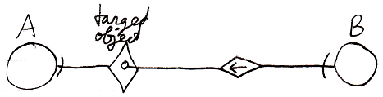

Calls to system commands are explained in the article Calling a System Command.

Another example of an alternative assignment, is to assign the final target of class redirections of one symbol as the class of another symbol. This is implemented as the a call to the Target Class system command and then assigning its return value as the class of the other symbol. Below is the expression of this in a diagram.

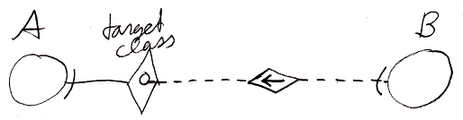

See also: Alternative Assignments, Assignment, Calling a System Command, Target Objects

Author & Copyright: Jan-Joost van Zon Date: July 26, 2008 – July 26, 2008 Location: Oosterhout, The Netherlands Status: Finished

